IELTS Writing Task 1 Simon

Contents

1. Line graph 2

1.1. Tips for Line graph 2

1.2. Internet Users as percentage of population 3

1.3. Internatioal migration in UK 4

1.4. UK acid rain emission 5

1.5. Water consumption 6

1.6. Car ownership 7

2. Bar chart 8

2.1. Marriages and divorces 8

2.2. Levels of participation 9

2.3. Consumer good 11

2.4. House prices 12

3. Table 13

3.1. Tips for table 13

3.2. Rail networks 14

3.3. Poverty proportion in Australia 15

3.4. Daily activities 16

3.5. Goods consumer 17

4. Pie chart 18

4.1. Cam7, page 101 18

4.2. Diet 19

5. Map 20

5.1. Village of Chorleywood 20

5.2. Gallery 21

5.3. House design 22

5.4. 2 proposed supermarket 23

6. Process 24

6.1. Tips for process diagram 24

6.2. Forecast in Australia 25

6.3. Brick manufactuting 26

6.4. Water cycle 27

# Line graph

## Tips for Line graph

Line graphs always show changes over time. Here's some advice about how to describe them:

* Try to write 4 paragraphs - introduction, summary of main points, 2 detail paragraphs.
* For your summary paragraph, look at the "big picture" - what changes happened to all of the lines from the beginning to the end of the period shown (i.e. from the first year to the last). Is there a trend that all of the lines follow (e.g. an overall increase)?
* You don't need to give numbers in your summary paragraph. Numbers are specific details. Just mention general things like 'overall change', 'highest' and 'lowest', without giving specific figures.
* Never describe each line separately. The examiner wants to see comparisons.
* If the graph shows years, you won't have time to mention all of them. The key years to describe are the first year and the last year. You should also mention any 'special' years (e.g. a peak or a significant rise/fall).
* Start describing details (paragraph 3) with a comparison of the lines for the first year shown on the graph (e.g. in 1990, the number of...).
* Use the past simple (increased, fell) for past years, and 'will' or 'is expected/predicted to' for future years.
* Don't use the passive (e.g. the number was increased), continuous (e.g. the number was increasing), or perfect tenses (e.g. the number has increased).

## Internet Users as percentage of population

[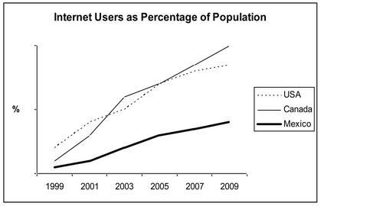](http://ielts-simon.com/.a/6a0120a5bb05d8970c0133f3433b15970b-pi)

The line graph compares the percentage of people in three countries who used the Internet between 1999 and 2009.

It is clear that the proportion of the population who used the Internet increased in each country over the period shown. Overall, a much larger percentage of Canadians and Americans had access to the Internet in comparison with Mexicans, and Canada experienced the fastest growth in Internet usage.

In 1999, the proportion of people using the Internet in the USA was about 20%. The figures for Canada and Mexico were lower, at about 10% and 5% respectively. In 2005, Internet usage in both the USA and Canada rose to around 70% of the population, while the figure for Mexico reached just over 25%.

By 2009, the percentage of Internet users was highest in Canada. Almost 100% of Canadians used the Internet, compared to about 80% of Americans and only 40% of Mexicans.

## International migration in UK

[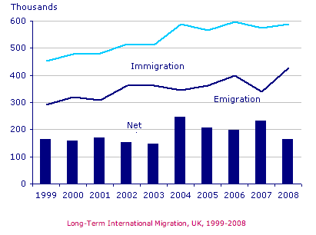](http://ielts-simon.com/.a/6a0120a5bb05d8970c0133f5936064970b-pi)

The chart gives information about UK immigration, emigration and net migration between 1999 and 2008.

Both immigration and emigration rates rose over the period shown, but the figures for immigration were significantly higher. Net migration peaked in 2004 and 2007.

In 1999, over 450,000 people came to live in the UK, while the number of people who emigrated stood at just under 300,000. The figure for net migration was around 160,000, and it remained at a similar level until 2003. From 1999 to 2004, the immigration rate rose by nearly 150,000 people, but there was a much smaller rise in emigration. Net migration peaked at almost 250,000 people in 2004.

After 2004, the rate of immigration remained high, but the number of people emigrating fluctuated. Emigration fell suddenly in 2007, before peaking at about 420,000 people in 2008. As a result, the net migration figure rose to around 240,000 in 2007, but fell back to around 160,000 in 2008.

(159)

## UK acid rain emission

***The graph below shows UK acid rain emissions, measured in millions of tones, from four different sectors between 1990 and 2007.***

***[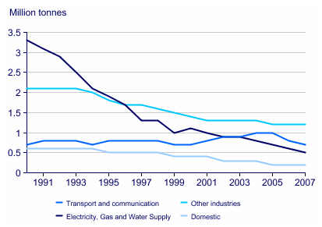](http://ielts-simon.com/.a/6a0120a5bb05d8970c0120a8cfa023970b-pi)***

***I've made the following essay into a gap-fill exercise.***

The line graph compares four sectors in ______ of the amount of acid rain emissions that they produced over a period of 17 years in the UK.

It is clear that the total amount of acid rain emissions in the UK ______ ______ between 1990 and 2007. The most ______ decrease was seen in the electricity, gas and water supply sector.

In 1990, around 3.3 million tones of acid rain emissions came from the electricity, gas and water sector. The transport and communication sector was ______ for about 0.7 million tones of emissions, while the domestic sector ______ around 0.6 million tones. Just over 2 million tones of acid rain gases came from other industries.

Emissions from electricity, gas and water supply fell dramatically to only 0.5 million tones in 2007, a ______ of almost 3 million tones. While acid rain gases from the domestic sector and other industries fell gradually, the transport sector ______ a small increase in emissions, ______ a peak of 1 million tones in 2005.

***Fill the gaps using these words:***

produced, reaching fell, responsible, saw, considerably, terms, drop, dramatic

## Water consumption

***The graph and table below give information about water use worldwide and water consumption in two different countries.***

[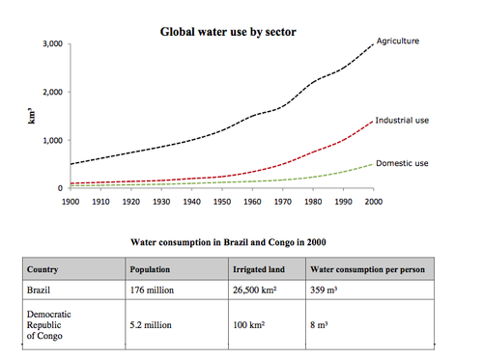](http://ielts-simon.com/.a/6a0120a5bb05d8970c0153940d0aee970b-pi)

The charts compare the amount of water used for agriculture, industry and homes around the world, and water use in Brazil and the Democratic Republic of Congo.

It is clear that global water needs rose significantly between 1900 and 2000, and that agriculture accounted for the largest proportion of water used. We can also see that water consumption was considerably higher in Brazil than in the Congo.

In 1900, around 500km³ of water was used by the agriculture sector worldwide. The figures for industrial and domestic water consumption stood at around one fifth of that amount. By 2000, global water use for agriculture had increased to around 3000km³, industrial water use had risen to just under half that amount, and domestic consumption had reached approximately 500km³.

In the year 2000, the populations of Brazil and the Congo were 176 million and 5.2 million respectively. Water consumption per person in Brazil, at 359m³, was much higher than that in the Congo, at only 8m³, and this could be explained by the fact that Brazil had 265 times more irrigated land.

(184 words, band 9)

## Car ownership

***The graph below gives information about car ownership in Britain from 1971 to 2007.***

[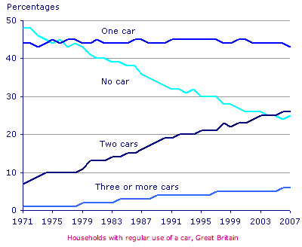](http://ielts-simon.com/.a/6a0120a5bb05d8970c0133f08ccc2a970b-pi)

The graph shows changes in the number of cars ______ household in Great Britain ______ a period of 36 years.

Overall, car ownership in Britain increased ______ 1971 and 2007. In particular, the number of households with two cars rose, while the number of households ______ a car fell.

In 1971, ______ half of all British households did not have regular use of a car. Around 44% of households had one car, but only about 7% had two cars. It was uncommon for families to own three or more cars, ______ around 2% of households falling into this category.

The one-car household was the most common type from the late 1970’s ______, although there was little change in the ______ for this category. The biggest change was seen in the proportion of households without a car, which fell steadily over the 36-year period ______ around 25% in 2007. In contrast, the proportion of two-car families rose steadily, reaching about 26% in 2007, and the proportion of households with more than two cars rose ______ around 5%.

***Fill the gaps in the essay with the following words:***

almost, to, figures, per, between, by, over, with, without, onwards

# Bar chart

## Marriages and divorces

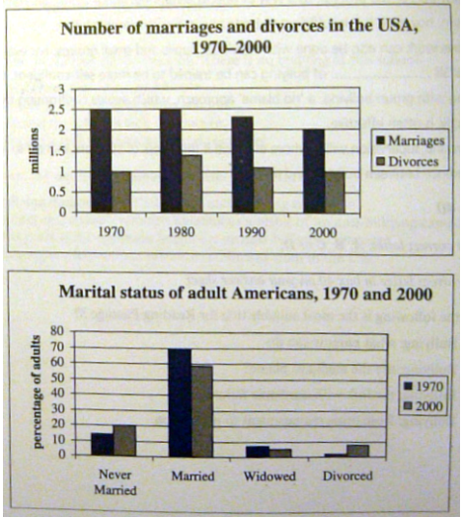

The ﬁrst bar chart shows changes in the number of marriages and divorces in the USA, and the second chart shows ﬁgures for the marital status of American adults in 1970 and 2000.

It is clear that there was a fall in the number of marriages in the USA between 1970 and 2000. The majority of adult Americans were married in both years, but the proportion of single adults was higher in 2000.

In 1970, there were 2.5 million marriages in the USA and 1 million divorces. The marriage rate remained stable in 1980, but fell to 2 million by the year 2000. In contrast, the divorce rate peaked in 1980, at nearly 1.5 million divorces, before falling back to 1 million at the end of the period.

Around 70% of American adults were married in 1970, but this ﬁgure dropped to just under 60% by 2000. At the same time, the proportion of unmarried people and divorcees rose by about 10% in total. The proportion of widowed Americans was slightly lower in 2000.

(174)

## Levels of participation

***The charts below show the levels of participation in education and science in developing and industrialised countries in 1980 and 1990.***

[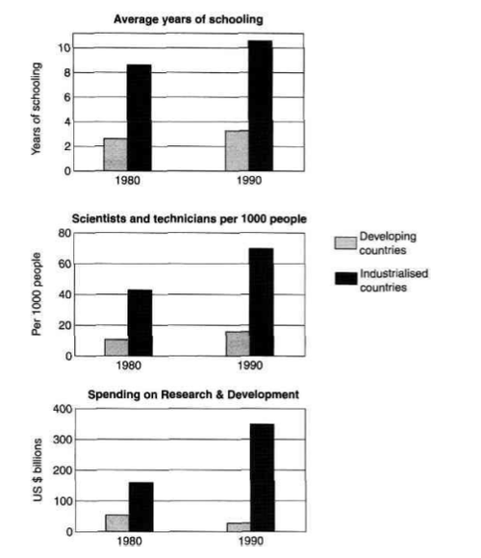](http://ielts-simon.com/.a/6a0120a5bb05d8970c0133f4d59ded970b-pi)

The three bar charts show average years of schooling, numbers of scientists and technicians, and research and development spending in developing and developed countries. Figures are given for 1980 and 1990.

It is clear from the charts that the figures for developed countries are much higher than those for developing nations. Also, the charts show an overall increase in participation in education and science from 1980 to 1990.

People in developing nations attended school for an average of around 3 years, with only a slight increase in years of schooling from 1980 to 1990. On the other hand, the figure for industrialised countries rose from nearly 9 years of schooling in 1980 to nearly 11 years in 1990.

From 1980 to 1990, the number of scientists and technicians in industrialised countries almost doubled to about 70 per 1000 people. Spending on research and development also saw rapid growth in these countries, reaching $350 billion in 1990. By contrast, the number of science workers in developing countries remained below 20 per 1000 people, and research spending fell from about $50 billion to only $25 billion.

(187 words)

## Consumer good

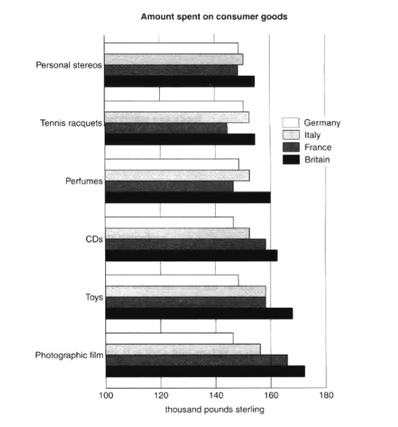

The bar chart compares consumer spending on six different items in Germany, Italy, France and Britain.

It is clear that British people spent significantly more money than people in the other three countries on all six goods. Of the six items, consumers spent the most money on photographic film.

People in Britain spent just over £170,000 on photographic film, which is the highest figure shown on the chart. By contrast, Germans were the lowest overall spenders, with roughly the same figures (just under £150,000) for each of the six products.

The figures for spending on toys were the same in both France and Italy, at nearly £160,000. However, while French people spent more than Italians on photographic film and CDs, Italians paid out more for personal stereos, tennis racquets and perfumes. The amount spent by French people on tennis racquets, around £145,000, is the lowest figure shown on the chart. *(154 words)*

## House prices

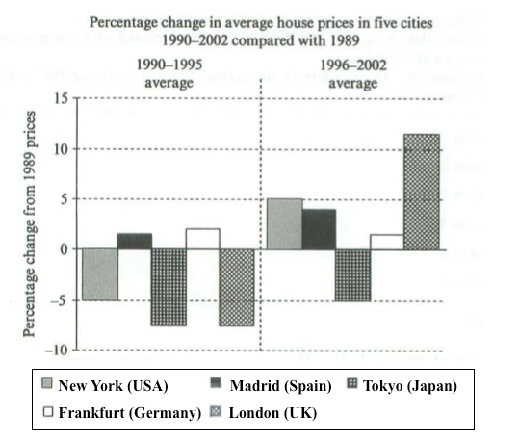

The bar chart compares the cost of an average house in five major cities over a period of 13 years from 1989.

We can see that house prices fell overall between 1990 and 1995, but most of the cities saw rising prices between 1996 and 2002. London experienced by far the greatest changes in house prices over the 13-year period.

Over the 5 years after 1989, the cost of average homes in Tokyo and London dropped by around 7%, while New York house prices went down by 5%. By contrast, prices rose by approximately 2% in both Madrid and Frankfurt.

Between 1996 and 2002, London house prices jumped to around 12% above the 1989 average. Homebuyers in New York also had to pay significantly more, with prices rising to 5% above the 1989 average, but homes in Tokyo remained cheaper than they were in 1989. The cost of an average home in Madrid rose by a further 2%, while prices in Frankfurt remained stable. *(165)*

# Table

## Tips for table

Tables seem difficult when they contain a lot of numbers. Here's some advice:

* Try to write 4 paragraphs - introduction, summary of main points, 2 detail paragraphs.
* Before you start writing, highlight some key numbers. Choose the biggest number in each category in the table (i.e. in each column and row). If the table shows years, look for the biggest changes in numbers over the time period. You could also mention the smallest numbers, but you can ignore 'middle' numbers (neither biggest nor smallest).
* For your summary paragraph, try to compare whole categories (columns or rows) rather than individual 'cells' in the table. If you can't compare whole categories, compare the biggest and smallest number. Write 2 sentences for the summary.
* In your two 'details' paragraphs, never describe each category (column or row) separately. The examiner wants to see comparisons. Try to organise the numbers you highlighted into 2 groups - one for each paragraph (e.g. highest numbers for all categories together, and lowest numbers together).
* Describe / compare the numbers you highlighted - include at least 3 numbers in each paragraph.
* Use the past simple for past years, and 'will' or 'is expected/predicted to' for future years. If no time is shown, use the present simple.

## Rail networks

***The table below gives information about the underground railway systems in six cities.***

[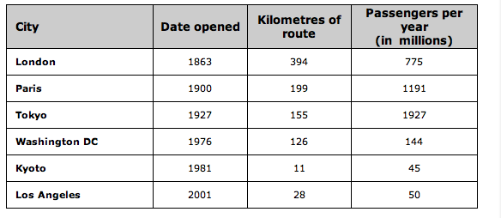](http://ielts-simon.com/.a/6a0120a5bb05d8970c0147e2f6c162970b-pi)

***Full essay (band 9):***

The table shows data about the underground rail networks in six major cities.

The table compares the six networks in terms of their age, size and the number of people who use them each year. It is clear that the three oldest underground systems are larger and serve significantly more passengers than the newer systems.

The London underground is the oldest system, having opened in 1863. It is also the largest system, with 394 kilometres of route. The second largest system, in Paris, is only about half the size of the London underground, with 199 kilometres of route. However, it serves more people per year. While only third in terms of size, the Tokyo system is easily the most used, with 1927 million passengers per year.

Of the three newer networks, the Washington DC underground is the most extensive, with 126 kilometres of route, compared to only 11 kilometres and 28 kilometres for the Kyoto and Los Angeles systems. The Los Angeles network is the newest, having opened in 2001, while the Kyoto network is the smallest and serves only 45 million passengers per year.

(185 words)

## Poverty proportion in Australia

***The table below shows the proportion of different categories of families living in poverty in Australia in 1999.***

[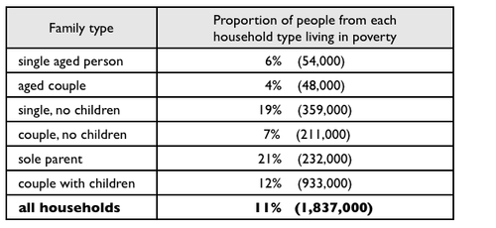](http://ielts-simon.com/.a/6a0120a5bb05d8970c015434c9f23f970c-pi)

The table gives information about poverty rates among six types of household in Australia in the year 1999.

It is noticeable that levels of poverty were higher for single people than for couples, and people with children were more likely to be poor than those without. Poverty rates were considerably lower among elderly people.

Overall, 11% of Australians, or 1,837,000 people, were living in poverty in 1999. Aged people were the least likely to be poor, with poverty levels of 6% and 4% for single aged people and aged couples respectively.

Just over one fifth of single parents were living in poverty, whereas only 12% of parents living with a partner were classed as poor. The same pattern can be seen for people with no children: while 19% of single people in this group were living below the poverty line, the figure for couples was much lower, at only 7%.

(150 words, band 9)

## Daily activities

***The chart below shows average hours and minutes spent by UK males and females on different daily activities.***

[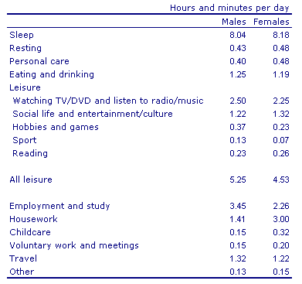](http://ielts-simon.com/.a/6a0120a5bb05d8970c0133ece0cc24970b-pi)

***I've made the following essay into a gap-fill exercise.***

The table compares the average ______ of time per day that men and women in the UK spend ______ different activities.

It is clear that people in the UK spend more time ______ than doing any other daily activity. Also, there are significant differences between the time ______ by men and women on employment/study and housework.

On average, men and women in the UK ______ for about 8 hours per day. Leisure ______ ______ the second largest proportion of their time. Men spend 5 hours and 25 minutes doing various leisure activities, such as watching TV or doing sport, ______ women have 4 hours and 53 minutes of leisure time.

It is noticeable that men work or study for an average of 79 minutes more than women every day. By contrast, women spend 79 minutes more than men doing housework, and they spend ______ ______ as much time looking after children.

***Fill the gaps using these words:*** doing, up, over, spent, while, sleeping, sleep, twice, amount, takes

## Goods consumer

***The table below gives information on consumer spending on different items in five different countries in 2002.***

Percentage of national consumer expenditure by category - 2002

[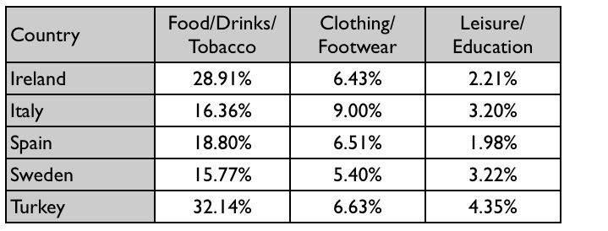](http://ielts-simon.com/.a/6a0120a5bb05d8970c0148c78b1eaf970c-pi)

The table shows percentages of consumer expenditure for three categories of products and services in five countries in 2002.

It is clear that the largest proportion of consumer spending in each country went on food, drinks and tobacco. On the other hand, the leisure/education category has the lowest percentages in the table.

Out of the five countries, consumer spending on food, drinks and tobacco was noticeably higher in Turkey, at 32.14%, and Ireland, at nearly 29%. The proportion of spending on leisure and education was also highest in Turkey, at 4.35%, while expenditure on clothing and footwear was significantly higher in Italy, at 9%, than in any of the other countries.

It can be seen that Sweden had the lowest percentages of national consumer expenditure for food/drinks/tobacco and for clothing/footwear, at nearly 16% and just over 5% respectively. Spain had slightly higher figures for these categories, but the lowest figure for leisure/education, at only 1.98%.

(155)

# Pie chart

## Cam7, page 101

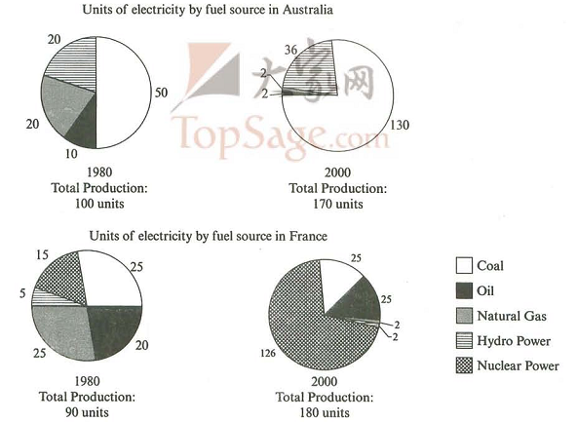

The pie charts compare the amount of electricity produced using five different sources of fuel in two countries over two separate years.

Total electricity production increased dramatically from 1980 to 2000 in both Australia and France. While the totals for both countries were similar, there were big differences in the fuel sources used.

Coal was used to produce 50 of the total 100 units of electricity in Australia in 1980, rising to 130 out of 170 units in 2000. By contrast, nuclear power became the most important fuel source in France in 2000, producing almost 75% of the country’s electricity.

Australia depended on hydro power for just under 25% of its electricity in both years, but the amount of electricity produced using this type of power fell from 5 to only 2 units in France. Oil, on the other hand, remained a relatively important fuel source in France, but its use declined in Australia. Both countries relied on natural gas for electricity production significantly more in 1980 than in 2000. (170 words)

## Diet

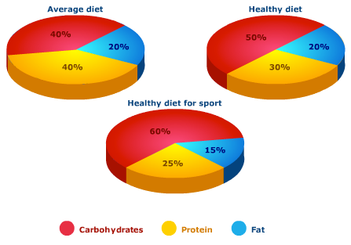

***Fill the gaps with these words:***  
***constitutes, drops, amount, fifth, higher, make, one, relative, figure, up***

The pie charts compare the proportion of carbohydrates, protein and fat in three different diets, namely an average diet, a healthy diet, and a healthy diet for sport.

It is noticeable that sportspeople require a diet comprising a significantly higher proportion of carbohydrates than an average diet or a healthy diet. The average diet contains the lowest percentage of carbohydrates but the highest proportion of protein.

Carbohydrates ______ ______ 60% of the healthy diet for sport. This is 10% ______ than the proportion of carbohydrates in a normal healthy diet, and 20% more than the proportion in an average diet. On the other hand, people who eat an average diet consume a greater ______ ______ of protein (40%) than those who eat a healthy diet (30%) and sportspeople (25%).

The third compound shown in the charts is fat. Fat ______ exactly ______ ______ of both the average diet and the healthy diet, but the ______ ______ to only 15% for the healthy sports diet.

# Map

## Village of Chorleywood

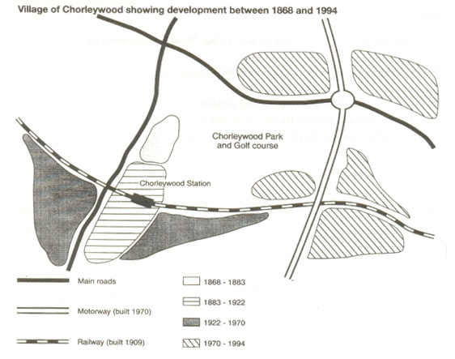

The map shows the growth of a village called Chorleywood between 1868 and 1994.

It is clear that the village grew as the transport infrastructure was improved. Four periods of development are shown on the map, and each of the populated areas is near to the main roads, the railway or the motorway.

From 1868 to 1883, Chorleywood covered a small area next to one of the main roads. Chorleywood Park and Golf Course is now located next to this original village area. The village grew along the main road to the south between 1883 and 1922, and in 1909 a railway line was built crossing this area from west to east. Chorleywood station is in this part of the village.

The expansion of Chorleywood continued to the east and west alongside the railway line until 1970. At that time, a motorway was built to the east of the village, and from 1970 to 1994, further development of the village took place around motorway intersections with the railway and one of the main roads.

(174)

## Gallery

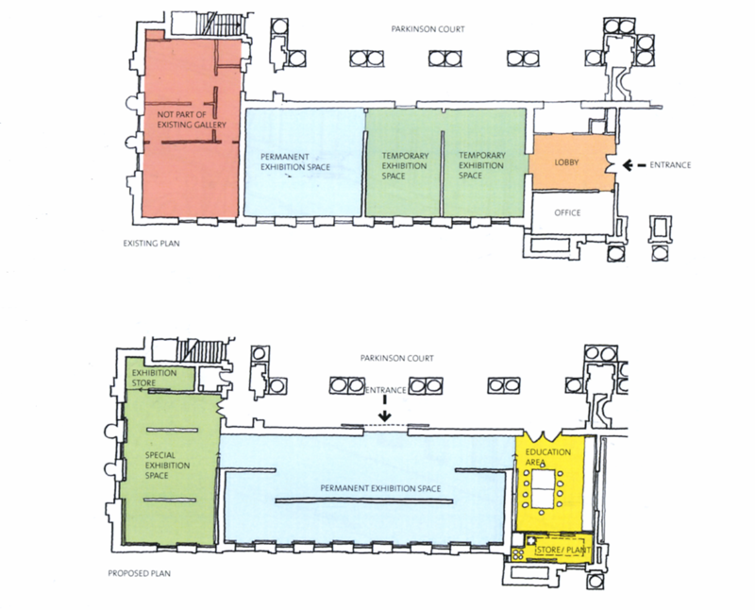

The first picture shows the layout of an art gallery, and the second shows some proposed changes to the gallery space.

It is clear that significant changes will be made in terms of the use of floor space in the gallery. There will be a completely new entrance and more space for exhibitions.

At present, visitors enter the gallery through doors which lead into a lobby. However, the plan is to move the entrance to the Parkinson Court side of the building, and visitors will walk straight into the exhibition area. In place of the lobby and office areas, which are shown on the existing plan, the new gallery plan shows an education area and a small storage area.

The permanent exhibition space in the redeveloped gallery will be about twice as large as it is now because it will occupy the area that is now used for temporary exhibitions. There will also be a new room for special exhibitions. This room is shown in red on the existing plan and is not currently part of the gallery. *(178 words, band 9)*

## House design

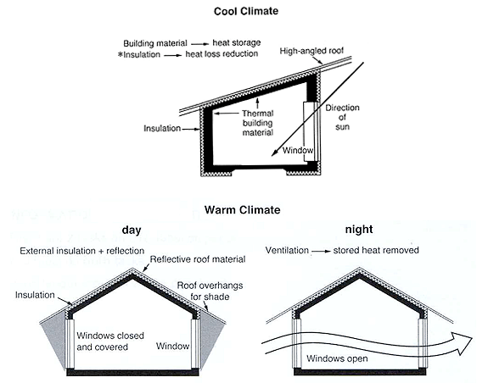

The diagrams show how house designs differ according to climate.

The most noticeable difference between houses designed for cool and warm climates is in the shape of the roof. The designs also differ with regard to the windows and the use of insulation.

We can see that the cool climate house has a high-angled roof, which allows sunlight to enter through the window. By contrast, the roof of the warm climate house has a peak in the middle and roof overhangs to shade the windows. Insulation and thermal building materials are used in cool climates to reduce heat loss, whereas insulation and reflective materials are used to keep the heat out in warm climates.

Finally, the cool climate house has one window which faces the direction of the sun, while the warm climate house has windows on two sides which are shaded from the sun. By opening the two windows at night, the house designed for warm climates can be ventilated.

(162 words, band 9)

## 2 proposed supermarket

***The map below is of the town of Garlsdon. A new supermarket (S) is planned for the town. The map shows two possible sites for the supermarket.***

[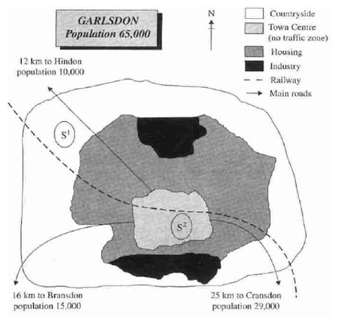](http://ielts-simon.com/.a/6a0120a5bb05d8970c01347fbc3651970c-pi)

The map shows two potential locations (S1 and S2) for a new supermarket in a town called Garlsdon.

The main difference between the two sites is that S1 is outside the town, whereas S2 is in the town centre. The sites can also be compared in terms of access by road or rail, and their positions relative to three smaller towns.

Looking at the information in more detail, S1 is in the countryside to the north west of Garlsdon, but it is close to the residential area of the town. S2 is also close to the housing area, which surrounds the town centre.

There are main roads from Hindon, Bransdon and Cransdon to Garlsdon town centre, but this is a no traffic zone, so there would be no access to S2 by car. By contrast, S1 lies on the main road to Hindon, but it would be more difficult to reach from Bransdon and Cransdon. Both supermarket sites are close to the railway that runs through Garlsdon from Hindon to Cransdon. *(171)*

# Process

## Tips for process diagram

Process diagrams show how something is done or made. They always show steps/stages. Here's some advice about how to describe them:

* Try to write 4 paragraphs - introduction, summary of main points, 2 detail paragraphs.
* Write the introduction by paraphrasing the question (rewrite it by changing some of the words).
* For your summary, first say how many steps there are in the process. Then say where/how the process begins and ends (look at the first and last stages).
* In paragraphs 3 and 4, describe the process step by step. Include the first and last steps that you mentioned in the summary, but try to describe them in more detail or in a different way.
* You could describe the steps in one paragraph, but it looks more organised if you break the description into two paragraphs. Just start paragraph 4 somewhere in the middle of the process.
* Mention every stage in the process.
* Use 'sequencing' language e.g. at the first / second / following / final stage of the process, next, after that, then, finally etc.
* Times (e.g. past dates) are not usually shown, so use the present simple tense.
* It's usually a good idea to use the passive e.g. 'At the final stage, the product is delivered to shops' (because we don't need to know who delivered the product).

## Forecast in Australia

***The diagram below shows how the Australian Bureau of Meteorology collects up- to-the-minute information on the weather in order to produce reliable forecasts.***

[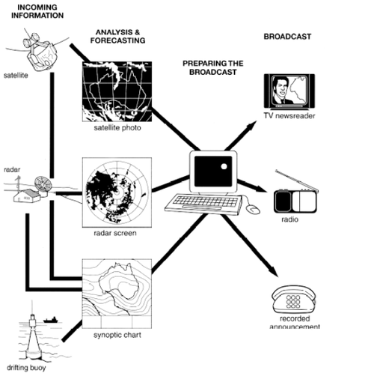](http://ielts-simon.com/.a/6a0120a5bb05d8970c0133f432ca94970b-pi)

The figure illustrates the process used by the Australian Bureau of Meteorology to forecast the weather.

There are four stages in the process, beginning with the collection of information about the weather. This information is then analysed, prepared for presentation, and finally broadcast to the public.

Looking at the first and second stages of the process, there are three ways of collecting weather data and three ways of analysing it. Firstly, incoming information can be received by satellite and presented for analysis as a satellite photo. The same data can also be passed to a radar station and presented on a radar screen or synoptic chart. Secondly, incoming information may be collected directly by radar and analysed on a radar screen or synoptic chart. Finally, drifting buoys also receive data which can be shown on a synoptic chart.

At the third stage of the process, the weather broadcast is prepared on computers. Finally, it is delivered to the public on television, on the radio, or as a recorded telephone announcement.

(170)

## Brick manufactuting

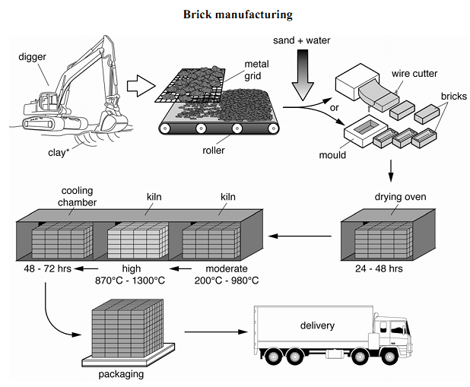

**Here are my 2 main paragraphs describing the steps:**

At the beginning of the process, clay is dug from the ground. The clay is put through a metal grid, and it passes onto a roller where it is mixed with sand and water. After that, the clay can be shaped into bricks in two ways: either it is put in a mould, or a wire cutter is used.

At the fourth stage in the process, the clay bricks are placed in a drying oven for one to two days. Next, the bricks are heated in a kiln at a moderate temperature (200 - 900 degrees Celsius) and then at a high temperature (up to 1300 degrees), before spending two to three days in a cooling chamber. Finally, the finished bricks are packaged and delivered.

## Water cycle

***The diagram below shows the water cycle, which is the continuous movement of water on, above and below the surface of the Earth.***

[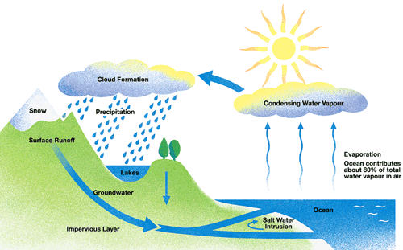](http://ielts-simon.com/.a/6a0120a5bb05d8970c014e60c42739970c-pi)

The picture illustrates the way in which water passes from ocean to air to land during the natural process known as the water cycle.

Three main stages are shown on the diagram. Ocean water evaporates, falls as rain, and eventually runs back into the oceans again.

Beginning at the evaporation stage, we can see that 80% of water vapour in the air comes from the oceans. Heat from the sun causes water to evaporate, and water vapour condenses to form clouds. At the second stage, labelled ‘precipitation’ on the diagram, water falls as rain or snow.

At the third stage in the cycle, rainwater may take various paths. Some of it may fall into lakes or return to the oceans via ‘surface runoff’. Otherwise, rainwater may filter through the ground, reaching the impervious layer of the earth. Salt water intrusion is shown to take place just before groundwater passes into the oceans to complete the cycle.

(156 words, band 9)